# Lab5 Problem 5: Determining the Magnetic Field of a Coil

**Rui Zuo ID:5323641**

**9 December,2016**

**Physics 1302W Professor: Clement Pryke TA: Saumitran Kasturirangan**

**Abstract**

**A coil of wire whose current, distance, radius and number of turns was determined. A current was initiated from one side of coil and run through the coil under the influence of the magnetic field. The B field was measured in different points along the axis running through the center of the coil. The basic equation of Biot-Savart Law which is used to predict the magnetic field is determined as $dB=\frac{μ_{0}}{4π}×\frac{Idlr}{r^{2}}$. The equation is proved to be correct. The equation of B-field in terms of the radius, current, and distance from coil is $B=\frac{{Nμ}_{0}Idl}{2\sqrt{R^{2}+z^{2}}} .$**

**Introduction**

**To accurately direct ion beams for cutting, the function of B-filed of a coil should be derived and used for calculation. To achieve this aim, we set up coil of wire was used to produce magnetic under constant current. We derive the predicted equation for the magnetic field as a function of measured constants and the distance from the center of the axis. The experimental values of magnetic field in different points were measured and recorded. These values will be compared were compared with prediction to prove the accuracy of the predicted equation.**

**Prediction**

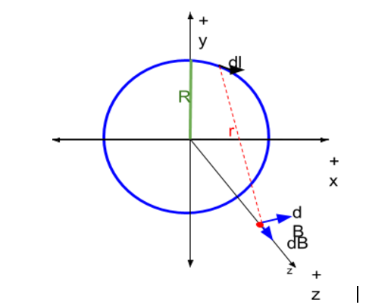

**Based on the Biot-Savart Law, we know the magnetic field of a current element is $dB=\frac{μ_{0}}{4π}×\frac{Idlr}{r^{2}}$, in other words $dB=\frac{μ_{0}}{4π}×\frac{Idl}{r^{2}}sinθ$. From the geometric view below , we could tell that $sinθ=\frac{R}{\sqrt{R^{2}+z^{2}}}$, R is the radius of coil , z is the distance from the center of coil following the the axis. From the equation below, we could derive the equation for the dB of this experiment as $dB_{z}=\frac{μ_{0}Idl}{4π{\left(R^{2}+z^{2}\right)}^{\frac{3}{2}}}$**

**And $B=dB_{z}×dl$. By calculating the integral of $dB_{z}$ we could derive the predited equation for dB as $B=\frac{μ_{0}Idl}{2\sqrt{R^{2}+z^{2}}}$. Because the coil has N turns, $B=\frac{{Nμ}_{0}Idl}{2\sqrt{R^{2}+z^{2}}}$. N is the number of turns for coil. I is current flowing through the coil, R is the radius of the loop and z is the distance from the center of loop along the z axis.**

**Procedure**

**Following the guideline of lab manual, we set up a coil of wire with 200 turns and radius of 0.105m. To measure the magnetic file, a probe was placed along the z-axis of the coil. When the coil was connected to the circuit and current flew through the coil. The probe was uniformly moved along the z-axis. In this process the magnetic field in different points was recorded.**

**Data:**

|  |  |  |  |
| --- | --- | --- | --- |
| Distance (cm) | Magnetic field (Gauss) | Distance (cm) | Magnetic field (Gauss) |
| -20.00 | 1.01 | 4.00 | 11.01 |
| -19.00 | 1.12 | 5.00 | 10.14 |
| -18.00 | 1.26 | 6.00 | 9.17 |
| -17.00 | 1.42 | 7.00 | 8.17 |
| -16.00 | 1.62 | 8.00 | 7.16 |
| -15.00 | 1.85 | 9.00 | 6.32 |
| -14.00 | 2.10 | 10.00 | 5.38 |
| -13.00 | 2.41 | 11.00 | 4.67 |
| -12.00 | 2.71 | 12.00 | 4.00 |
| -11.00 | 3.20 | 13.00 | 3.45 |
| -10.00 | 3.66 | 14.00 | 3.00 |
| -9.00 | 4.19 | 15.00 | 2.60 |
| -8.00 | 4.90 | 16.00 | 2.26 |
| -7.00 | 5.64 | 17.00 | 1.97 |
| -6.00 | 6.52 | 18.00 | 1.72 |
| -5.00 | 7.55 | 19.00 | 1.52 |
| -4.00 | 8.41 | 20.00 | 1.35 |
| -3.00 | 9.53 | 21.00 | 1.19 |
| -2.00 | 10.41 | 22.00 | 1.07 |
| -1.00 | 11.28 | 23.00 | 0.95 |
| 0.00 | 11.85 | 24.00 | 0.85 |
| 1.00 | 12.12 | 25.00 | 0.76 |
| 2.00 | 12.06 |  |  |
| 3.00 | 11.73 |  |  |

**Table1:**

**This table is built with 2 sets. The distance along the z-axis which run through the center of coil and corresponding magnetic field measured in experiment.**

**Analysis**

**The real location of the center of the coil can’t be determined precisely in the experiment. To make the experimental data more coordinated with the theoretical data set. We offset the distance of experimental data by 1 cm. The graphed the B-field of experimental data and Theoretical data in teslas. The x-axis of graph is the distance in meters.**

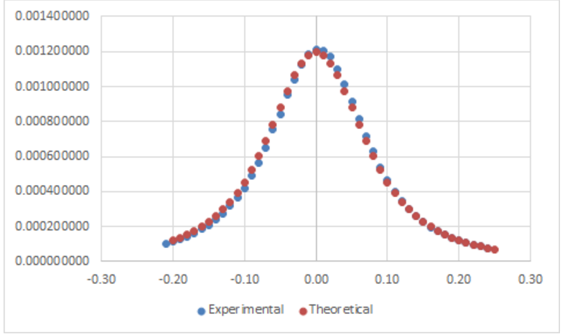

**Figure1: The unit of this figure in x-axis is ‘m’ and in y-axis is ‘tesla’.**

**From this graph we could tell that two data sets is reasonably close. To get a linear-line graph and perform a error analysis we plot the graph of B-field which set $\frac{1}{\sqrt{R^{2}+Z^{2}}}$ as x-axis.**

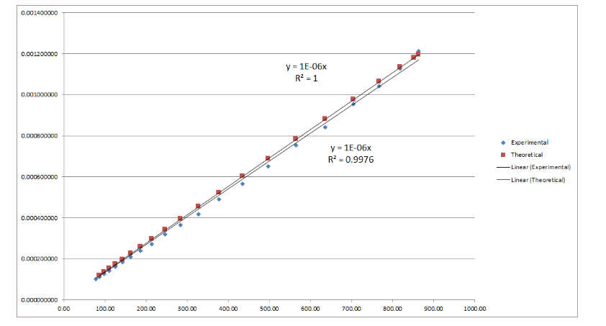

**From the equation $∆_{slope}=\frac{b}{\sqrt{N-2}}\sqrt{\frac{1}{R}}-1$ we get the uncertainty of slope which is only**

$7.39×10^{-9}$**. Under such result, the accuracy of the derived equation could be proved in this experiment.**

**Conclusion:**

**The function of the b-field in terms of the radius, current, and distance from coil was derived and proved to be correct through process of experiment and comparison of experimental and theoretical data sets. The aim of this experiment is achieved.**